Revised School Timetable for Lockdown

The school has set 1 hour of English and 1 hour of Maths per day.

 | 8.30 | 8.45 | 9.00 | 9.15 | 9.30 | 9.45 | 10.00 | 10.15 | 10.30 | 10.45 | 11.00 | 11.15 | 11.30 | 11.45 | 12.00 | 12.15 | 12.30 | 12.45 | 13.00 | 13.15 | 13.30 | 13.45 |  | 14.00 | 14.15 | 14.30 |  | 14.45 | 15.00
Mon | Get ready for school, set up schoolroom. | Joe Wicks PE Lesson |  | 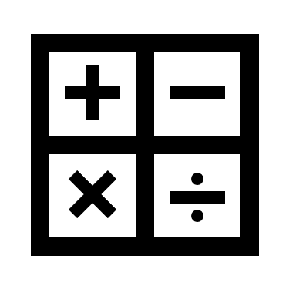  School Maths |  |  | Maths Challenge |  | Play time | Spellings & Grammar from school |  | School English |  |  | Read | Lunch time  (Eat lunch at 12.55) |  |  |  | Maths Colouring |  | Activity set by teacher |  |  |  |  |  | Duolingo
Tues |  |  |  | Cello |  | Duolingo |  |  |  | Grammar sheet from home |  | School Maths |  |  | Read |  |  |  |  | Mathsframe.com |  | School  English |  |  |  |  |  | Art
 |  |  |  |  |  | Check messages from teacher
Wed |  |  |  | Music - keyboard |  |  | Times Tables Colouring |  |  | School English |  |  | School  Maths |  |  |  |  |  |  | Spelling test & Handwriting sheet |  | FaceTime activity with a friend |  |  |  |  | Cello practice
Thurs |  |  |  | Mathsframe.co.uk |  |  | Grammar from School |  |  | Cosmic Kids Yoga |  |  | School English |  |  |  |  |  |  | School Maths |  |  | Outschool Lesson |  |  |  |  | Read
Fri |  |  |  | Check messages from teacher |  |  | Read |  |  | School English |  |  | School Maths |  |  |  |  |  |  | Times Tables Colouring |  | Activity set by teacher |  |  |  |  |  | FaceTime activity with a friend

 | Monday | Tuesday | Wednesday | Thursday | Friday
After School | Chill out | Dancing | Sewing | Fun homework | Chill out.
Out of the house walk or cycle

